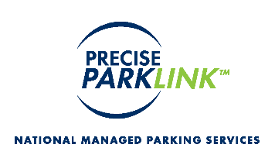

CHARLTON CAMPUS
50 Charlton Ave. East, Hamilton ON

PARKING RATES as of April 16, 2021

Charlton Lot (no coupons or monthly passes)
entrance located off of Charlton Ave

Each ½ hour (or portion thereof) $ 3.75
Each additional ½ hour (or portion thereof) $ 3.75
Daily maximum per visit $26.00
Lost ticket (daily maximum applies) $26.00
Day Pass Not applicable
H Pass Not applicable
No in and out privileges

Ramp #3
Entrance located off of James Street

Each ½ hour (or portion thereof) $ 3.75
Each additional ½ hour (or portion thereof) $ 3.75
Daily maximum per visit $21.00
Day Pass $21.00
Lost ticket (daily maximum applies) $21.00

1 Month consecutive day pass $95.00

H PASS (valid for one year from date of purchase)
5 Day non-consecutive day pass $ 50.00**
10 Day non-consecutive day pass $100.00**
30 Day non-consecutive day pass $250.00**
- transferrable between patients and caregivers
- in-and-out privileges throughout a 24 hour period
- good for one year from the date of purchase
- useable at both the West 5th and Charlton sites
- **non-refundable / only valid for Ramp 3 parking access

To purchase either the multi-day H Pass or the 1 month consecutive day pass, please visit the Parking Office located on the 1st floor of the Juravinski Tower (Charlton site) or Level 1 – Room D160A (West 5th).

